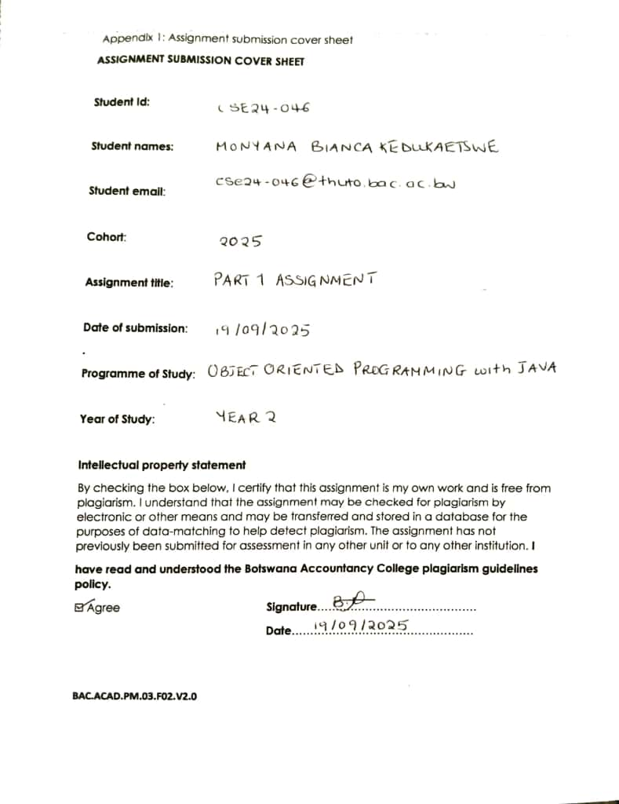

**PART A: SYSTEM DOCUMENTATION**

1. **REQUIREMENT ELICITATION**
   1. FUNCTIONAL REQUIREMENTS

* Customer should be able to make deposits to any account.
* Monthly interests must be fully automated.
* Interest application should be recorded as a value in the transaction history.
* Bank Teller should capture customer details(firstname & lastname, omang ID, date of birth for individuals. Company name, company number, date of establishment for companies), address to open account for customer.
* Customer should provide employment information to open a cheque account.
* Customer should pay P500.00 to open an investment account and P50.00 to open a savings account.
* System should allow a customer to open multiple types of accounts.
* System should ensure that monthly, 0.025 % is applied to customer savings account, 0.075 % is applied to company savings account and 5% is applied to any investment account.
* The customer should provide login details for access( username and password). And should be able to reset the login details when needed.

* 1. NON FUNCTIONAL REQUIREMENTS
* The system should have fast response time around 3 miniseconds.
* The system should provide 24/7 access.
* All transactions should be logged into the system.
* The system should be updated once in every six months.
* The customer should be alerted and retry if the system encounters a failed transaction.

**2.STRUCTURAL UML MODELLING**

2.1 SYSTEM USE CASE DIAGRAM

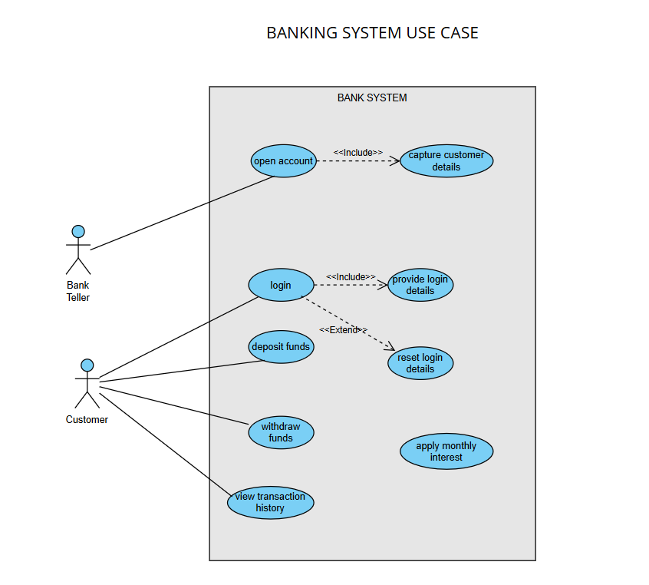

2.2 CLASS DIAGRAM

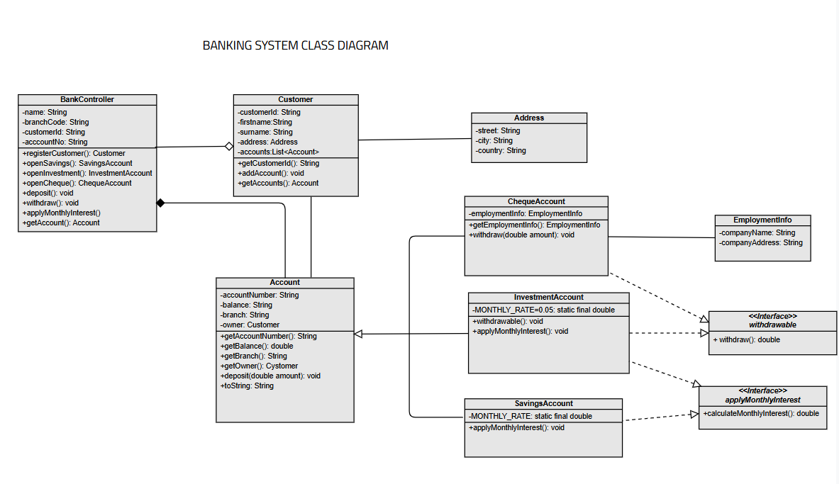

**3. BEHAVIORAL UML MODELLING**

3.1

ACCOUNT OPENING SEQUENCE DIAGRAM

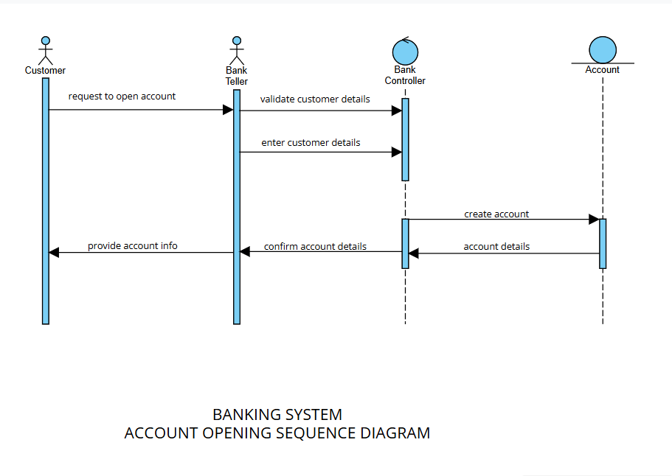

DEPOSIT FUNDS SEQUENCE DIAGRAM

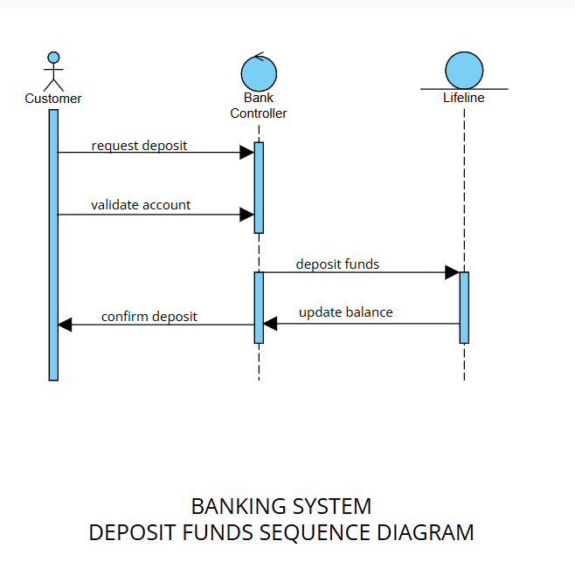

3.2 WITHDRAWAL STATE MACHINE DIAGRAM

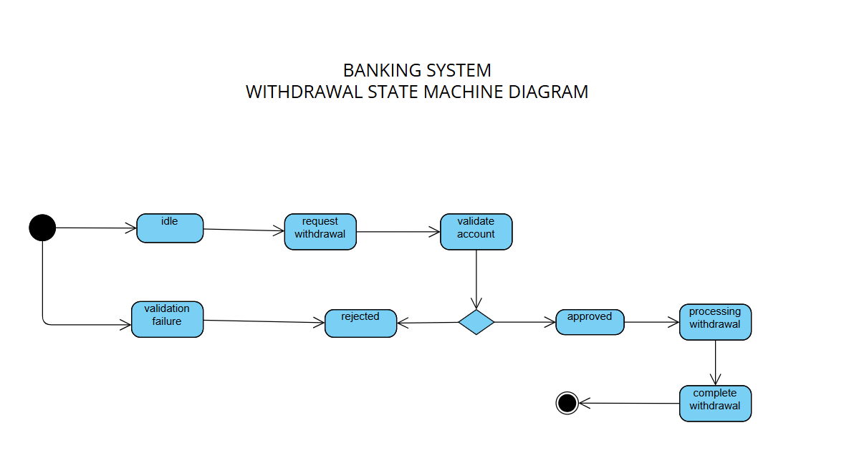

**APPENDIX A: FUNCTIONAL REQUIREMENTS INTERVIEW RECORD**

Date: 18/09/2025

Interviewer: Monyana Bianca Kedukaetswe

Interviewee: Mr Themba Moeng & Mr Kentsenao Baseka (Bank Managers)

Purpose: To gather functional requirements for the Banking System Project

INTERVIEW TRANSCRIPT

Q1: Which accounts can the customer be able to deposit to?

A1: They should be able to make deposits to any account.

Q2: Does the monthly interest require human approval before finalization or should it be fully automated?

A2:Fully automated.

Q3:With the interest application, should it be recorded as rate or value in the transaction history?

A3: It should be logged as a value.

Q4:What details should the bank teller capture when opening an account for a customer?

A4: They should capture; firstname, lastname, ID number and date of birth for individuals. Company name, company number and establishment date for companies along with addresses.

Q5: What is needed for a customer to open a cheque account?

A5: They should provide employment information; Company name, Company Address, Position.

Q6: How much is needed for initial deposits when opening a savings account and when opening an investment account?

A6: Customer should pay P50.00 to open a savings account and P500.00 to open an investment account.

Q7: Should the system allow a customer to open multiple account types?

A7: Yes.

Q8: What interest rates apply to savings accounts and investments account?

A8: System should ensure that monthly, 0.025 % is applied to customer savings account, 0.075 % is applied to company savings account and 5% is applied to any investment account.

Q9: For access to the system, what should the customer provide?

A9: The customer should provide login details like username and password and the are also able to reset them when needed.

**APPENDIX B: NON- FUNCTIONAL REQUIREMENTS INTERVIEW RECORD**

Date: 18/09/2025

Interviewer: Monyana Bianca Kedukaetswe

Interviewee: Mr Themba Moeng

Purpose: To gather non- functional requirements for the Banking System project

INTERVIEW TRANSCRIPT

Q1:How fast should critical transactions be processed

A1: The system’s response time should be around 3 miniseconds

Q2:Should the system provide 24/7 access including weekends and public holidays?

A2: Yes it should be able to do so.

Q3: Which transactions should be logged into the transaction history?

A3: All transactions should be recorded into the transaction history for fraud detection and auditing.

Q4: How often should the system be updated?

A4: Once every six months

Q5: What should happen if the system encounters a failed transaction?

A5:There should be an alert message and an option for the customer to retry the transaction.